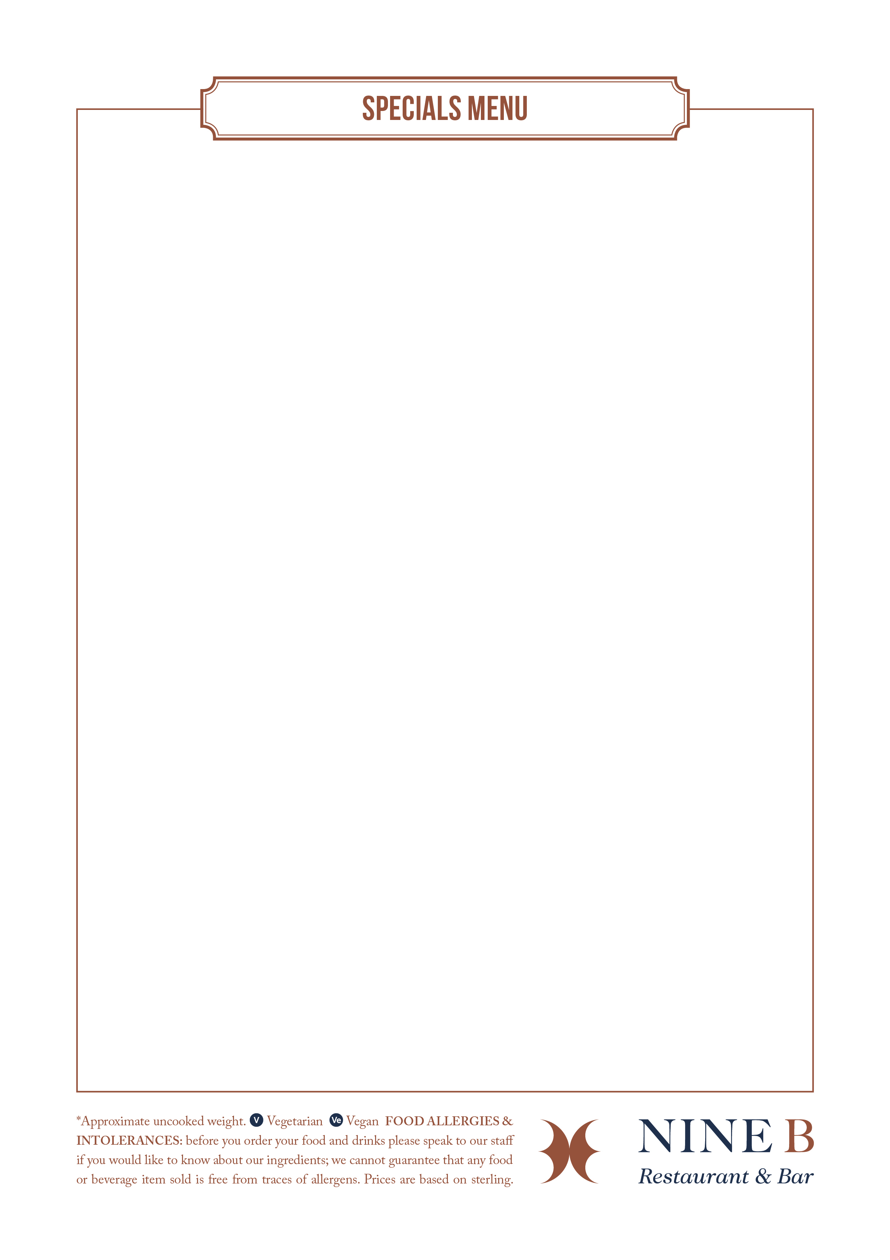

**LUNCH**

**12 Noon – 6 pm**

**STARTER**

**Soup of the day,** sour dough bread (VE) **5.25**

**Calamari,** lemon mayo, rocket and cherry tomato salad **6.00**

**Cajun Halloumi fries,** spicy yogurt (V) **5.25**

**Smoked Haddock & Spring Onion Fish Cake,** poached egg, cheddar cheese and parsley sauce **6.50**

**Crispy Cauliflower**, sweet chilli sauce (VE) **4.50**

**Spicy Vietnamese meatballs,** carrot and lime salad **6.50**

**Bread platter & mixed olives,** olive oil and balsamic **5.50**

**Breaded spicy BBQ chicken wings,** slaw, mint and lemon dressing **6.00**

**MAINS**

**Battered Cod**, thick chips, peas **14.00**

­**­Classic Cesar Salad,** lettuce, parmesan, Caesar dressing, croutons, Anchovies **12.00**

*Add Chicken/Salmon*  **2.50**

**Chicken Schnitzel,** garlic butter, chunky chips, mixed salad **14.00**

­­**Halloumi Burger**, thick chips, avocado, pesto mayo, and sriracha  **12.00**

­­**8oz Beef burger**, thick chips, relish **14.00**

*Add bacon, or mature cheddar cheese, or stilton cheese* **2.00**

­­

**DESSERTS**

**Dark Chocolate Coconut Tart** with lemon sorbet (VE) **6.00**

**Classic lemon tart** with vanilla ice cream **6.00**

**Warm Sticky Toffee Pudding** with custard **6.00**

**Strawberry Cheesecake**, strawberry ice cream **6.00**

**Ice Cream & Sorbet Selections** (3 scoops) **6.00**

**Deli Sandwiches**

*All served with choice of ciabatta bread or bloomer or gluten free bread, crisp and coleslaw*

Mature cheddar cheese and sweet pickle (V) **6.50**

Honey roast ham and English mustard **7.50**

Smoked Scottish salmon, dill cream cheese **8.50**

Free-range egg and cress (V) **6.50**

**Hot** (On Ciabatta bread)

Pan Fried Minute Steak, caramelised onion chutney, grain mustard mayonnaise **9.50**

Club Sandwich with chicken, Egg mayo, bacon and cos lettuce **9.50 Cuban Panini,** pulled pork**,** spiced sweet potato fries **8.50**

*Gluten free options available. Items may change subject to availability.*